Name:

2.2 Cell Metabolism | Objectives
2.2.5 Respiration | - Definition of the term: aerobic respiration.  - Explain the role of aerobic respiration – what does it do for organisms?  - Express aerobic respiration by a balanced equation.  - State the nature of respiration from syllabus – what stages are involved, where do these take place, what happens?  - Definition of the term: anaerobic respiration.  - Express anaerobic respiration by a balanced equation.  - State the nature and role of fermentation.  - State the cellular location of the first & second stage.  - Explain the role of microorganisms in fermentation.  - Explain the role of microorganisms including bioprocessing and Bioreactors
2.2.8.H The role of ATP and NAD | - Explain the role of ATP and describe how it is formed from ADP + P  - Explain the role of NADP+ in trapping and transferring electrons and hydrogen ions in cell activities
2.2.10.H Respiration extended study | - State the first stage reaction: Glycolysis  - Explain the difference in the fermentation option.  - State the second stage reaction: Krebs Cycle

Respiration is the enzyme controlled release of energy from food by living cells.
Aerobic respiration uses oxygen.

C₆H₁₂O₆ + 6O ₂ → 6H₂O + 6CO₂ + 2820 kJ
(plants & animals)

Energy released is stored as ATP – which is the immediate source of energy in the cell (“energy currency” of cell)

Anaerobic respiration is the breakdown of sugar to release energy in the absence of oxygen. It occurs in some bacteria and most animal cells e.g. muscle cells during strenuous exercise. End product is lactic acid. This reduces the efficiency of the cells. The acidity lowers the pH which slows down enzyme action and causes cramps and stiffness. The deeper and faster breathing at the end of strenuous exercise is needed to convert the lactic acid back into glucose in the liver.
C₆H₁₂O₆ → 2CH₃CH(OH)COOH + 150 kJ
Lactic acid

C₆H₁₂O₆ → 2C₂H₅OH + 2CO₂ + 210 kJ
(ethanol)
(plants, fungi & some bacteria)

 | Aerobic Respiration | Anaerobic respiration
Oxygen present /absent
Amount of energy released
Takes place in:
Number of stages:
Products: |  | In plants and fungi =  In animals =
Equation: |  | Plants and fungi:  Animal:

Fermentation is the anaerobic respiration of sugars. It is an example of biotechnology - the manufacture of a useful product using living things. Bacteria and fungi are the main organisms used. Plants and animals can also be used.
Biological advantages of fermentation:
Source of energy in oxygen-deficient environments.
Disadvantages:
Only 2 ATPs produced compared to 38 ATPs per glucose in aerobic respiration. Products are also toxic and have to be excreted.
Examples of bioprocessing:
Microbe | Product | Uses
Bacteria | Antibiotics | Kill bacteria
 | Yoghurt, cheese | Food
 | Enzymes | Washing powder
 | Hormones | e.g. insulin for diabetics
Yeast | Ethanol | Beer, Wine making
 | CO₂ | Raising of bread, soft drinks

ATP = Adenosine triphosphate, found in all cells, has a role in the transfer of energy.
energy rich bonds (34 kJ)
Adenine
(Base)
Ribose
(5C sugar)
P
P
P

low energy bond (12 kJ)
ATP is an energy courier as it is v. soluble and diffuses rapidly. Also referred to as the ‘energy currency’ of the cell. Mitochondria are often seen in high numbers where a large amount of ATP is needed.
ADP + Energy + P → ATP and vv
ATP is found in small quantities in all living cells. It can be broken down and remade very quickly. 60% of the released energy in respiration is in the form of heat.
40% of the energy released in respiration is used for heat (body temp 37ºC), absorption of mineral nutrients by plant roots, reabsorption of glucose by kidney cells, protein synthesis, DNA replication, cell growth, muscle contraction, cell division.

Energy sources for ATP formation
ATP can be produced from light, oxidation of inorganic & organic compounds (above).
Light – ATP is produced in the light stage of photosynthesis when light is absorbed by chlorophyll in chloroplasts and is used in the dark stage (anabolic reactions).
Chemical: some autotrophic bacteria produced ATP from the oxidation of inorganic compounds. The ATP is used to make carbohydrate from CO₂ in a process similar to the dark stage of p/s.

Biochemistry of respiration
.
Stage 1: Glycolysis – oxygen-independent stage
Stage 2: Kreb’s Cycle and Electron Transport Chain - oxygen-dependent stage
.
Glycolysis:
Glycolysis is the breakdown of glucose into two pyruvates in the cytosol (= complex liquid of cytoplasm in which the cell organelles are suspended).
Glucose is ‘energised’ (phosphorylated) by adding 2 phosphates to it from 2 ATP molecules. This 6-C compound is unstable and is then converted, in a series of steps, into 2 pyruvates. 4 ATPs are formed in the process, but allowing for the 2 ATPs used initially there is a net gain of 2 ATPS.
∴ glucose → 2 pyruvates + 4H + 2 ATP

If oxygen is not present, the pyruvates are converted into either lactic acid or ethanol and carbon dioxide.

Kreb’s Cycle
The pyruvate now enters the matrix/lumen of the mitochondrion where it loses CO₂ and 2H. The remaining 2C, acetyl group is attached to a carrier molecule, co-enzyme A, to form acetyl coenzyme A. The acetyl group is passed by co-enzyme A into a series of reactions called the Kreb’s cycle. A 4C compound bonds to the acetyl group forming a 6C compound. The co-enzyme A is detached and recycled. This 6C compound is converted in steps back to the 4C compound by losing two CO₂s and 4 hydrogen pairs. One ATP is also released.

Electron transport chain
i.e. the formation of ATP in the cristae using oxygen.
The electrons from the 2 H atoms are passed along a series of carrier molecules and the energy released in each transfer is used to make ATP. The hydrogen ions and electrons finally unite with oxygen to form water.
The water may be used by the cell.

Role of NAD⁺ is to pick up and transfer electrons (NAD – Nicotinamide adenine dinucleotide)
.
NAD⁺ receives two electrons when it picks up two hydrogen atoms.
NAD⁺ + 2H → NADH + H⁺
NADH passes the two electrons on to an electron transport chain and NAD⁺ is reformed. Therefore NADH is an energy source for ATP formation.
NADH → NAD⁺ + H⁺ + 2e⁻
NAD⁺ can also function as a tightly bound coenzyme. Its ability to receive and give electrons plays a vital role in the activity of specific enzymes.

Industrial fermentation refers to the growth and use of m/o in liquid in presence or absence of oxygen.
In a bioreactor (usually a large stainless steel vessel) m/o are grown in a liquid culture medium that has a suitable substrate (e.g. yeast with glucose). Air is pumped in and product (e.g. alcohol) is removed. The contents of the bioreactor are mixed to bring the microbes into contact with the substrate.

Bioprocessing with immobilised cells:
M/o are often fixed or immobilised for use in a bioreactor.
Microbe cells may be:
- Attached to each other
- Attached to an insoluble support e.g. glass beads
- Enclosed in a gel or membrane (e.g. alginate)
Advantages of using immobilised cells:
- A gentle procedure (doesn’t damage cells – longer life, more efficient)
- Cells can be recovered easily and so product is purer.
- They can be reused & therefore they are economical
In addition, advantages with continuous bioreactors:
- Easier, quicker, cheaper production of product on a large scale.
- Constant high efficiency of production.
- Easier purification of product as filtration is not required to remove reactor cells.

Uses of immobilised cells:
Production of fertilisers, steroids, alcohol, vinegars, artificial antibiotics.

Beer manufacture
Malting –grain is dampened and kept warm to allow the barley to germinate. Then the malt is dried and stored. To start fermentation, the malt is ground with water to allow the enzyme, amylase, to convert the starch to sugar. More barley can be added to increase the starch supply.
The solution is then boiled, to stop the amylase working. Hops (and maybe sugar) are added after filtering the mixture – enhance flavour and reduce growth of unwanted bacteria.
Starter culture of Saccharomyces is added and allowed to ferment for about a week. The beer is filtered to remove the yeast and then barrelled or bottled for distribution.
Alternatively, the yeast cells can be immobilised in sodium alginate beads. The sugar solution is passed down through a bioreactor of these beads and alcohol is collected at the bottom (sugar can enter beads via pores and alcohol/CO₂ can diffuse out. Yeast cells are too big to pass out). The bioreactor can be continuously used without the need to stop the reaction and separate the cells from the alcohol.

Mandatory expt.: To investigate fermentation by Saccharomyces cerevisiae

Section A

SEC Sample Paper HL
2. Select the correct term from the following list to match each of the terms in column A and write it in
column B.
protein, enzyme, uracil, sap, ethanol, mutation, thymine, chlorophyll.

A | B
Fermentation

2006 HL
4. (a) What is the first stage process of respiration called? ……………………………
(b) In this first stage there is a release of ATP as glucose is converted to another substance.
Name this other substance ……………………………………….
(c) To what is the substance you have named in (b) converted under anaerobic conditions in:
1. Yeast? ……………….……………………..
2. A human muscle cell?………………………
(d) Under aerobic conditions the substance that you have named in (b) is converted to an acetyl
group and in the process a small molecule is released.
Name this small molecule. ………………………………………………….
(e) The acetyl group now enters a cycle of reactions.
What name is given to this cycle?...........................................................................
(f) Where in the cell does this cycle take place? ……………………......................

2008 HL
5. (a) Write a balanced equation on the line below to represent aerobic respiration.
……………………………………………………………………………………………………….
(b) The first stage of respiration takes place in the cytosol. What is the cytosol?
……………………………………………………………………………………………………….
(c) Does the first stage of respiration release a small or large amount of energy? ……………………….
(d) What is fermentation? …………………………………………………………………………………
…………………………………………………………………………………………………………
(e) Where in the cell does the second stage of aerobic respiration take place?..………………………….
(f) Is oxygen required for the second stage of aerobic respiration? ……………………………………..
(g) Suggest a situation in which some cells in the human body may not be able to engage in the second stage of aerobic respiration…………………………………………..…………………………………………

2011HL
6. Cellular respiration may occur in one stage or two stages.
(a) Give two differences, other than location, between Stage 1 and Stage 2.
(i) ______________________________________________________________________________
(ii) _____________________________________________________________________________
(b) Where in a cell does Stage 1 occur?
________________________________________________________________________________
(c) What term is used to describe respiration in which only Stage 1 occurs?
________________________________________________________________________________
(d) Name a chemical end product of the type of respiration referred to in (c).
________________________________________________________________________________
(e) In Stage 2 of respiration electrons pass along an electron transport chain, releasing energy. In what
molecule is this energy stored in the cell?
________________________________________________________________________________
(f) To what are these electrons transferred at the end of the electron transport chain?
________________________________________________________________________________
2014 Q6

2017HL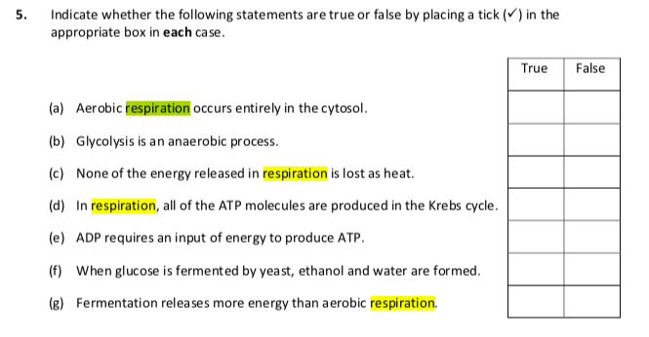
Section B
2004 HL
7. (a) Yeast cells produce ethanol (alcohol) in a process called fermentation.
Is this process affected by temperature? …………………………………….……………………..
Explain your answer ……………………………………………………….………………………
………………………………………………………………………………………………………
………………………………………………………………………………………………………
……………………………………....................................................................................................
(b) Answer the following in relation to an experiment to prepare and show the presence of ethanol using yeast.
Draw a labelled diagram of the apparatus that you used.

Name a substance that yeast can use to make ethanol. ………………………………………………………………………………………………………………………………………………………………………………………………
What substance, other than ethanol, is produced during fermentation? ………………………………………………………………………………………………
Describe the control that you used in this experiment. ………………………………………………………………………………………………………………………………………………………………………………………………………………………………………………………………………………………………
Explain the purpose of a control in a scientific experiment. ………………………………………………………………………………………………………………………………………………………………………………………………………………………………………………………………………………………………
How did you know when the fermentation was finished? ………………………………………………………………………………………………………………………………………………………………………………………………………………………………………………………………………………………………
Why were solutions of potassium iodide and sodium hypochlorite added to the reaction vessels after a certain period of time? ……………………………………….
Name a substance produced during aerobic respiration that is not produced during fermentation. ………………………………………..

2006 HL
7. (b) In the case of each of the following state:
1. An investigation in which you used it,
2. The precise purpose for its use in the investigation that you have indicated.

(iv) Alkaline pyrogallol or anaerobic jar
1…………………….……………………………………………………………
2………………..…………………………...........................................................

2012 HL
7. (b) Answer the following by reference to some of the investigations that you carried out in the course of
your studies.
(ii) How did you show that alcohol was present when investigating the production of alcohol by
yeast?
________________________________________________________________________________
________________________________________________________________________________

Section C
2005 HL
11. (a) (i) Distinguish between aerobic and anaerobic respiration.
(ii) Write a balanced equation to summarise aerobic respiration. (9)

(b) Answer the following questions in relation to the first stage of respiration.
(i) Where in the cell does this stage occur?
(ii) During this stage a small amount of energy is released. Explain the role of ADP in relation to this released energy.
(iii) What is the final product of this stage under aerobic conditions?
(iv) If conditions in the cell remain aerobic the product you have named in (iii) is used for the second stage of respiration. Where does this second stage take place?
(v) If conditions in a human cell (e.g. muscle) become anaerobic the product named in (iii) is converted to another substance. Name this other substance.
(vi) When the substance named in (v) builds up in the blood, a person is said to be in oxygen debt. This debt must eventually be paid. Suggest how the debt is paid. (24)

(c) If yeast cells are kept in anaerobic conditions alcohol (ethanol) and another substance are produced.
(i) Describe, with the aid of a diagram, how you would keep yeast under anaerobic conditions in the laboratory.
(ii) Name a carbohydrate that you would supply to the yeast as an energy source.
(iii) Give an account of a chemical test to demonstrate that alcohol (ethanol) has been produced. Include the initial colour and final colour of the test.
(iv What is the other substance produced under anaerobic conditions?
(v) Alcohol (ethanol) production is an example of fermentation. How would you know when fermentation has ceased?
(vi) Why does fermentation eventually cease? (27)

2007 HL
11. (a) (i) For what is ATP an abbreviation?
(ii) What is the role of ATP in cells? (9)

(b) (i) What name is given to the first stage of respiration?
(ii) Where in a cell does this first stage take place?
(iii) To what substance is glucose normally converted in this first stage of respiration?
(iv) Is oxygen required for this conversion?
(v) Name a compound to which the substance that you have named in (iii) may be converted, in the absence of oxygen.
(vi) In aerobic respiration, the product of the first stage moves to the mitochondrion.
Outline subsequent events in the total breakdown of this product. (27)

2009 HL
12. (b) (i) What name is given to the first stage of respiration?
(ii) The first stage ends with the formation of pyruvate (pyruvic acid).
In anaerobic conditions, what is produced from this pyruvate:
1. In muscle cells?
2. In yeast cells?
(iii) If conditions are aerobic, pyruvate next passes to an organelle in which the second stage of respiration takes place. Name this organelle.
(iv) In this organelle pyruvate is broken down to CO₂ and a two-carbon compound. Name this two-carbon compound.
(v) This two-carbon compound passes directly into a series of reactions in the second stage of respiration.
Name this series of reactions and give one product, other than electrons, of these reactions.
(vi) The electrons released from the above reactions pass along a transport chain and in the process energy is releasd.
1. To what use is this energy put?
2. At the end of the transport chain what happens to the electrons?
2012 HL
12. (9)
(c) Write a brief note on each of the following items in relation to respiration.
(i) Glycolysis.
(ii) Acetyl Co-enzyme A.
(iii) Adenosine triphosphate.
(iv) Electron transport chain. (24)
2013 HL
14. (b) Write notes on each of the following topics. You are required to make a minimum of three points
concerning each topic. Marks will not be given for word diagrams alone.
(ii) Krebs Cycle.
(iii) ADP.
(c) (i) Explain the term fermentation.
(ii) Name an organism that is used in industrial fermentation.
(iii) To which kingdom does this organism belong?
(iv) Name a compound which is used as a carbon source in the fermentation referred to in part (ii).
(v) In industrial fermentations bioprocessing with immobilised cells is sometimes used.
1. Explain the terms bioprocessing and immobilised.
2. Give an advantage of using immobilised cells.
3. Name the compound from which the immobilising beads are formed in the laboratory.
4. Give the general name for the vessel used for such reactions.
2015 HL Q12

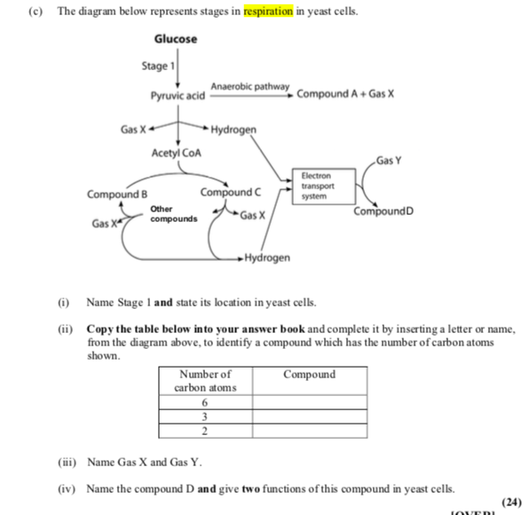
2016 HL Q11

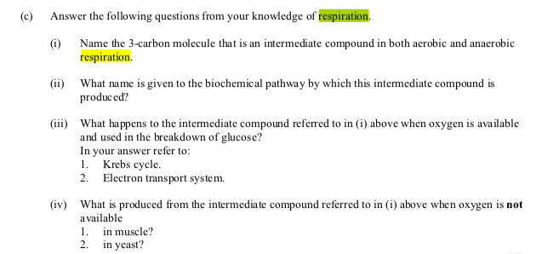

2018 HL Q12

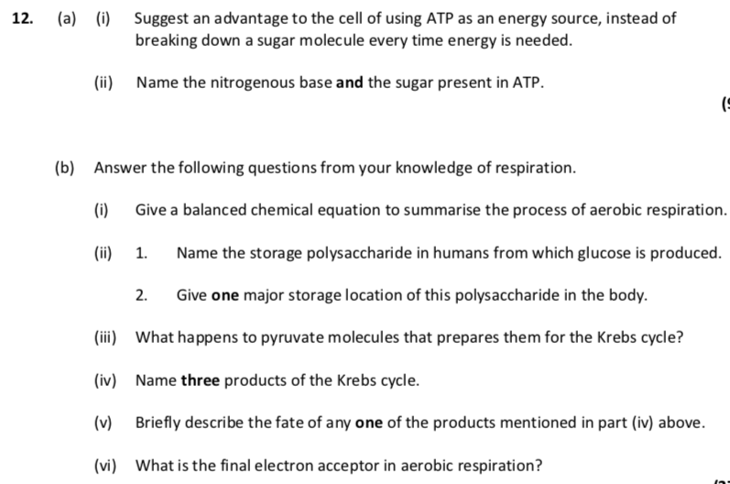

Ordinary Level
2004 OL
3. Indicate whether each of the following statements is true (T) or false (F) by drawing a circle around T or F.
Aerobic respiration is the release of energy in the absence of oxygen T F

2008 OL
3. Indicate whether the following are true (T) or false (F) by drawing a circle around T or F.
Example: Carbon dioxide is produced during respiration. T F
(a) Stage 1 of respiration requires oxygen T F
(b) Stage 1 of respiration takes place in the cytoplasm T F
(c) Stage 2 of respiration also takes place in the cytoplasm T F
(d) Some of the energy released in respiration is lost as heat T F
(e) Lactic acid is a product of anaerobic respiration T F

2011 OL
5. Choose each term from the following list and place it in Column B to match a description in
Column A. The first one has been completed as an example.

Alcohol, Oxygen, Water, Mitochondria, Lactic acid, Large

Column A | Column B
The amount of energy released in aerobic respiration. | Large
(i) A substance required for aerobic respiration.
(ii) A product of anaerobic respiration in muscles.
(iii) A product of aerobic respiration.
(iv) A product of anaerobic respiration in yeast.
(v) The cell structures in which Stage 2 of aerobic respiration
takes place.

SEC Sample Paper OL
13. (a) (i) Complete the following equation, which is a summary of aerobic respiration.
C₆H₁₂O₆ + 6O₂
(ii) Aerobic respiration is a two-stage process. The first stage takes place in the cytoplasm. Where does the second stage take place? (9)

(b) The apparatus below may be used to demonstrate aerobic respiration. Air is drawn through the apparatus by attaching it to a vacuum pump at X. Sodium hydroxide is placed in flask 1 to remove carbon dioxide.

(i) What is the purpose of removing carbon dioxide?
(ii) Limewater is put in flasks 2 and 3. Suggest a reason for putting it in each flask.
(iii) What is the purpose of a control in an experiment? Suggest a suitable control for this experiment.
(iv) If the animal in the apparatus were replaced by a plant, and the experiment carried out in daylight, would you expect a similar result? Explain your answer. (24)

(c) The apparatus below may be used to demonstrate anaerobic respiration in yeast.
The water was boiled and cooled before adding the yeast.

(i) Why was the water boiled before adding the yeast?
(ii) Why do you think a layer of oil has been put on top of the water?
(iii) Would the same apparatus containing water and yeast but without sugar be a suitable control? Explain your answer.
(iv) Give two industrial uses of the anaerobic respiration of yeast. (27)

2005 OL
11. (c) (i) Some of the carbohydrates produced in photosynthesis are used in respiration. What is
respiration?
(ii) Suggest one reason why living organisms need to respire.
(iii) What is aerobic respiration?
(iv) Respiration can also be anaerobic. Which of the two types of respiration releases more energy?
(v) Anaerobic respiration by micro-organisms is called fermentation. Give one example of industrial fermentation, including the type of micro-organism and the substance produced. (27)

2006 OL
13. (a) (i) Identify X and Y in the following equation which is a summary of aerobic respiration.
C₆H₁₂O₆ + 6X → 6Y + 6H₂O
(ii) What is anaerobic respiration? (9)

(b) Answer the following questions in relation to aerobic respiration as a two stage process.
(i) Where in the cell does the first stage take place?
(ii) Does the first stage require oxygen?
(iii) Comment on the amount of energy released in the first stage.
(iv) Where in the cell does the second stage take place?
(v) Does the second stage require oxygen?
(vi) Comment on the amount of energy released in the second stage.
(vii) State two ways in which the energy that is released is used in the human body. (24)

(c) (i) Describe how you used yeast to produce alcohol (ethanol). Include a labelled diagram of the
apparatus that you used.
(ii) How did you show that alcohol had been produced? (27)

2007 OL
12. (a) (i) Explain briefly what is meant by respiration.
(ii) Distinguish between aerobic and anaerobic respiration. (9)

(b) (i) Copy the table below into your answer book and complete the final column.

Type of Respiration | Energy Source | End Products
Aerobic respiration | Glucose
Anaerobic respiration in muscle | Glucose
Anaerobic respiration in yeast | Glucose

(ii) In stage 1 of respiration, glucose is partly broken down. Where in the cell does this happen?
(iii) Name the cell component shown in the diagram in which stage 2 of respiration takes place.

(iv) Which stage of respiration releases more energy? (24)

(c) (i) Draw a labelled diagram of the apparatus in which you used yeast to produce alcohol.
(ii) The water that you used in the apparatus was previously boiled and cooled. Why was this?
(iii) In your investigation it was necessary to exclude air. How was this done?
(iv) Describe briefly a test to show that alcohol had been produced. (27)

2009 OL
12. (b) (v) Some bacteria are anaerobic. What does this mean?

2009 OL
15. (b) (i) What is meant by the term aerobic respiration?
(ii) Aerobic respiration takes place in two main stages – stage 1 and stage 2.
Indicate clearly in your answer book whether each of the following statements refers to stage 1 or to stage 2.
A. Takes place in the mitochondria.
B. Produces a large amount of energy.
C. Takes place in the cytoplasm.
D. Does not require oxygen.
(iii) One of your practical activities was to prepare alcohol using yeast. In your answer book answer the following questions in relation to this activity:
A. Name the solution in which you placed the yeast at the start of the activity.
B. Give the temperature at which you then kept the solution.
C. How did you know that alcohol production had ceased?
D. Name the test or chemical(s) used to show that alcohol had been produced.

2010 OL
12.
(b) (i) Which biological process is represented by the following word equation:
glucose + oxygen → carbon dioxide + water + energy?
(ii) The above process occurs in two stages, Stage 1 and Stage 2, that take place in different
parts of the cell.
Say where in the cell Stage 1 occurs and where in the cell Stage 2 occurs.
(iii) Does the whole process release a large amount or a small amount of energy?
(iv) Write a word equation to show what happens when yeast breaks down glucose
in the absence of oxygen.
(v) Give one industrial application of this process.
(vi) When muscles break down glucose in the absence of oxygen, one main product is
produced. Name this product. (27)

2012 OL
14.
(a) (i) What is meant by aerobic respiration?
(ii) Aerobic respiration takes place in two stages.
1. Where in a cell does stage 1 occur?
2. Where in a cell does stage 2 occur?
(iii) Which type of respiration, aerobic or anaerobic, produces more energy?
(iv) In yeast cells, alcohol is produced by fermentation.
Draw a labelled diagram showing how alcohol may be produced in the laboratory.
Answer the following questions in relation to the activity:
1. Name another substance that is produced during the fermentation process.
2. How would you detect this other substance?
3. How would you know when fermentation had finished?

2013 OL
13. (c) Answer the following questions in relation to an investigation you carried out into fermentation by
yeast cells.
(i) Explain what is meant by anaerobic respiration.
(ii) Where in the cell does anaerobic respiration occur?
(iii) Describe, with the aid of a diagram, how you kept the yeast under anaerobic conditions during the
investigation.
(iv) Name the two substances produced by the yeast in the process of fermentation.
(v) How did you know that fermentation had ceased? (24)

Marking scheme

2004 HL Sample Q2
6(3)+2
A | B
Fermentation | Ethanol

2006 HL Q4
4. |  |  | 6(3)+2
 | (a) | glycolysis
 | (b) | pyruvic acid or pyruvate
 | (c) | 1. ethanol  2. lactic acid or lactate
 | (d) | carbon dioxide
 | (e) | Krebs or citric acid or tricarboxylic acid (cycle)
 | (f) | Mitochondrion

2008 HL Q5
5. |  | 6(3) + 2
 | (a) | C6H12O6 + 6O2 → 6CO2 + 6H2O (+energy)
 | (b) | cytoplasm minus organelles (or structures or particles) or liquid part of  cytoplasm
 | (c) | Small
 | (d) | anaerobic respiration or respiration that produces alcohol or respiration  that produces lactic acid
 | (e) | Mitochondrion
 | (f) | Yes
 | (g) | lack of oxygen or exercise or restricted blood supply

2011 HL Q6
6. |  | 6(3) + 2
 | (a) | (i), (ii) Stage 1 does not require O₂ or is anaerobic  produces a small amount of energy (or ATP)
 | (b) | Cytoplasm or cytosol
 | (c) | Anaerobic or fermentation
 | (d) | Ethanol or lactic acid or CO₂
 | (e) | ATP
 | (f) | Oxygen or H⁺ (or protons)

2014 Q6

2

2017 HL Q5

Section B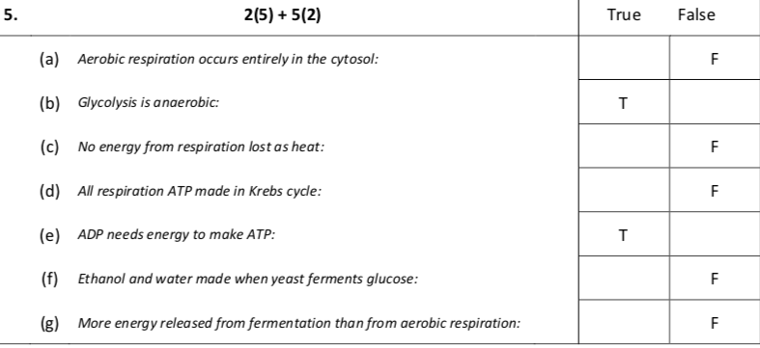

2004 HL Q7
7. | (a) |  | Yes | 3
 |  |  | (Rate of) enzyme reaction (affected by temperature) | 3
 | (b) |  | Diagram  [must include evidence of anaerobic conditions and two correct labels for 3 marks] | 3, 0
 |  |  | Sugar or named sugar or starch | 3
 |  |  | Carbon dioxide or any product of glycolysis | 3
 |  |  | Yeast absent (or dead) in same set up | 3
 |  |  | Comparison or purpose described | 3
 |  |  | No more gas given off (no more bubbles) | 3
 |  |  | *NB - To test for alcohol – All candidates who attempt Q | 3
 |  |  | Water (allow other correct product from Kreb’s cycle) | 3

2006 HL Q7
7 | (b) | (iv) | 1. to investigate conditions for germination  2. to remove oxygen  [accept ‘without oxygen’] | 3  3

2012 HL Q7
7 | (b) | (ii) | Named chemicals or named test | 3

Section C

2005 HL Q11
11. | (a) | (i) | Aerobic respiration requires oxygen or anaerobic respiration does not | 3
 |  | (ii) | C₆H₁₂O₆ + 6O₂ → 6H₂0 + 6CO₂ | 6, 3, 0
 | (b) | (i) | Cytoplasm | 3
 |  | (ii) | Uses energy / combines with phosphate / to form ATP/ ATP stores energy / high energy bond / energy transferred (by ATP)  any three | 3(3)
 |  | (iii) | Pyruvic acid (Pyruvate) | 3
 |  | (iv) | Mitochondrion | 3
 |  | (v) | Lactic acid | 3
 |  | (vi) | Increased breathing (deeper or faster) or reference to oxidation of lactic acid or increased oxygen | 3
 | (c) | (i) | Diagram - vessel plus anaerobic conditions  Label (comment) relating to anaerobic conditions | 3  3
 |  | (ii) | Sugar or named sugar or starch | 3
 |  | (iii) | First reagent(s) or test named / any procedural point / initial colour / final colour /  any three  (Potassium) dichromate / add acid or warm / orange / to green  Iodoform test or potassium iodide / add sodium hypochlorite or warm / colourless / to yellow | 3(3)
 |  | (iv) | Carbon dioxide | 3
 |  | (v) | No more bubbles given off | 3
 |  | (vi) | Alcohol kills yeast or yeast dies or sugar used up | 3

2007 HL Q11
11. | (a) | (i) | Adenosine Triphosphate | 3
 |  | (ii) | stores or provides or described / energy | 2(3)
 | (b) | (i) | glycolysis* | 3
 |  | (ii) | cytoplasm* or cytosol | 3
 |  | (iii) | pyruvate* or pyruvic acid | 3
 |  | (iv) | no* | 3
 |  | (v) | lactic acid or ethanol | 3
 |  | (vi) | (begins with) acetyl co-enzyme A / Krebs cycle / release of carbon dioxide / H release / transport system / ATP formed / O₂ required / H₂O produced | 4(3)

2009 HL Q12
12 | (b) | (i) | Glycolysis | 3
 |  | (ii) | 1. Lactate (lactic acid)  2. Ethanol (and CO₂) | 3  3
 |  | (iii) | Mitochondrion | 3
 |  | (iv) | Acetyl (Co-enzyme A) | 3
 |  | (v) | Krebs cycle  CO₂ or ATP or Hydrogen ions or protons | 3  3
 |  | (vi) | 1. Forming ATP (or described)  2. To oxygen or involved in H₂O formation | 3  3

2012 HL Q12
12 | (c) | (i) | First stage of respiration / in cytoplasm (or in cytosol) / anaerobic / starts with glucose (or indicated) / produces pyruvate / low energy release | 2(3)
 |  | (ii) | Aerobic / formed from pyruvate / 2-carbon (group) / joins Krebs cycle / in mitochondrion | 2(3)
 |  | (iii) | High energy bonds (or high energy molecule) / energy store / releases energy / forming ADP (or formed from ADP) / large ATP production in stage 2 | 2(3)
 |  | (iv) | Aerobic / in mitochondrion / carries high-energy electrons / from NADH or from Krebs cycle / to protons / formation of water / ATP produced or high energy release | 2(3)

2013 HL Q14(b)
14. | (b) | If any ‘note’ consists only of a word diagram, flow-chart or chemical equation, then a maximum of two scoring points may be awarded.
 |  | (i) | Metabolism: (The sum of) all reactions in cell (or organism) / controlled by enzymes / catabolism explained or catabolism + example / anabolism explained or anabolism + example | 4+2(3)
 |  | (ii) | Krebs Cycle: occurs in second stage of respiration / in mitochondria / when O₂ present (or aerobic) / starts with Acetyl Co-enzyme A / ATP produced / hydrogen (pairs) produced or energised electrons / CO₂ produced | 4+2(3)
 |  | (iii) | ADP: Adenosine Di-phosphate / a low energy (molecule) / + phosphate (P) / + energy / ATP formed | 4+2(3)

2013 HL Q14(c)
14. | (c) | (i) | Anaerobic respiration |  |  | 3
 |  | (ii) | Yeast |  |  | 3
 |  | (iii) | *Fungi |  |  | 3
 |  | (iv) | Any named carbohydrate |  |  | 3
 |  | (v) | 1. | Bioprocessing: | using micro-organisms (or enzymes) / to form product(s) | 2(3)
 |  |  |  | Immobilised: | fixed to inert material (or named material) or fixed to each other or trapped in gel (or named material) | 3
 |  |  | 2. | Can be re-used (or recovered) or pure product (or described) |  | 3
 |  |  | 3. | Alginate |  | 3
 |  |  | 4. | Bioreactor |  | 3

2015 HL Q12

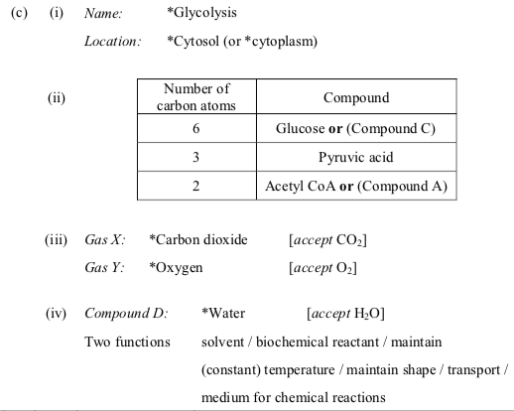

2016 HL Q11
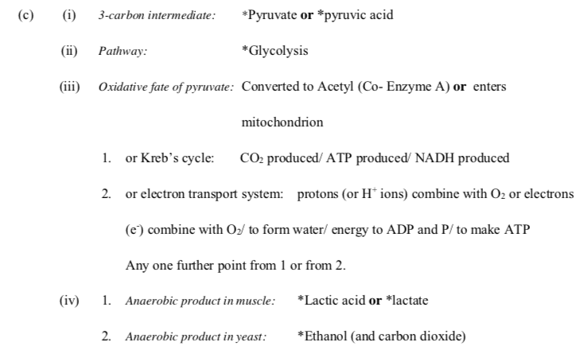

2018 Hl Q12

2004 OL Q3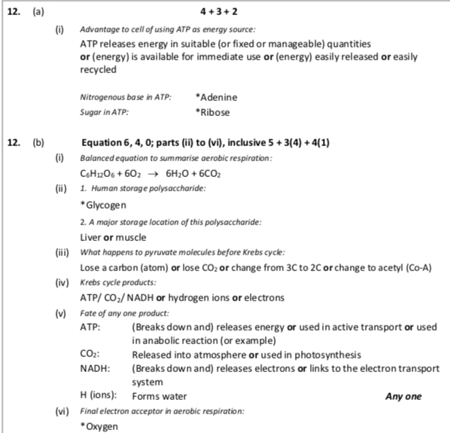

3. |  |  | 2(5)+5(2)
 | (c) | F

2008 OL Q3
3. |  |  |  | 2(7)+3+2+1
 | (a) | Stage 1 of respiration requires oxygen | F
 | (b) | Stage 1 of respiration takes place in the cytoplasm | T
 | (c) | Stage 2 of respiration also takes place in the cytoplasm | F
 | (d) | Some of the energy released in respiration is lost as heat | T
 | (e) | Lactic acid is a product of anaerobic respiration | T

2011 OL Q5
5. |  |  |  | 2(7) + 3(2)
 | (i) |  | A substance required for aerobic respiration. Oxygen
 | (ii) |  | A product of anaerobic respiration in muscles. Lactic Acid
 | (iii) |  | A product of aerobic respiration. Water
 | (iv) |  | A product of anaerobic respiration in yeast. Alcohol
 | (v) |  | The cell structures in which Stage 2 occurs. Mitochondria

2004 OL Sample Q13
13. | (a) | (i) | 6CO₂ + 6H₂O + energy | 2(3)
 |  | (ii) | Mitochondria | 3
 | (b) | (i) | To show that it is the mouse that releases the carbon dioxide | 3
 |  | (ii) | Lime water in 2 proves that any carbon dioxide in the incoming air has been removed.  Lime water in 3 proves that it is the mouse that releases the CO₂ | 3  3
 |  | (iii) | To act as a comparison/ a standard against which to compare.  The same set up but with no mouse ( organism) | 6  3
 |  | (iv) | No.  Photosynthesis by the plant would use up the CO₂ that the plant produces in respiration | 3  3
 | (c) | (i) | To remove the oxygen | 6
 |  | (ii) | To keep the system anaerobic/ to stop oxygen getting in | 6
 |  | (iii) | No.  The control would be the set up without the yeast. It is the yeast that is respiring. | 3  6
 |  | (iv) | Baking / brewing | 2(3)

2005 OL Q11
11 | (c) | (i) | release of energy/ oxidation of food | 6
 |  | (ii) | to provide energy or named metabolic activity | 6
 |  | (iii) | respiration in presence of oxygen | 6
 |  | (iv) | aerobic | 3
 |  | (v) | allow any example of “industrial fermentation” | 2(3)
  Organism (3) | Product (3)
  Bacteria | beer/ wine/ yoghurt/ enzymes/ drugs/ hormones/ antibiotics/methane (biogas)/ etc.
  Fungus / Yeast | carbon dioxide/ wine/ beer/ single cell protein/ antibiotics

2006 OL Q13
13. | (a) | (i) | X = oxygen Y = carbon dioxide | 5+1
 |  | (ii) | (energy release) not requiring oxygen or air or correct equation | 3
 | (b) |  |  | 4(5)+4(1)
 |  | (i) | Cytoplasm
 |  | (ii) | No
 |  | (iii) | Small amount
 |  | (iv) | Mitochondrion
 |  | (v) | Yes
 |  | (vi) | Large amount or much greater than first
 |  | (vii) | Muscular activity/ nerve impulse/ maintenance of body temperature/ reabsorption in kidney/respiration any two
 | (c) | (i) | diagram of apparatus  (Diagram with solution = 3 and correct label = 3)  (Description: Labels or points)  Container/yeast/ water/ sugar/ fermentation lock or Bunsen valve/ control/ incubate / boiling / cooling / oil / time /ethanol (alcohol) / CO₂ produced  any four | 6, 3, 0  4(5)
 |  | (ii) | Name of test or reagent / initial colour/final colour  H₂SO₄ (acidified) + Potassium (sodium) dichromate – orange to green  Iodoform test - brown to yellow | 1

2007 OL Q12
12.
 | (a) | (i) | release of energy/ from food or basic equation  (carbohydrate or named + oxygen/ carbon dioxide + water + energy) | 2(3)
 |  | (ii) | (aerobic respiration) needs oxygen or (anaerobic respiration) does not need oxygen | 3
 | (b) | (i) |  | 2(3)  3  2(3)
  Type of respiration | Energy Source | End products
  Aerobic respiration | Glucose | carbon dioxide/ water / ATP
  Anaerobic respiration in muscle | Glucose | lactic acid
  Anaerobic respiration by yeast | Glucose | alcohol/ carbon dioxide/ATP
 |  | (ii) | cytoplasm or cytosol | 3
 |  | (iii) | mitochondrion | 3
 |  | (iv) | stage 2 [allow aerobic] | 3
 | (c) | (i) | diagram (glass container, anaerobic method, solution)  [one missing 3 marks, two missing 0 marks]  labels | 6, 3, 0  3(2)
 |  | (ii) | to remove oxygen or air or to sterilise water or to prevent yeast death or to prevent enzyme denaturation | 3
 |  | (iii) | layer of oil or fermentation trap | 3
 |  | (iv) | reagent/ condition (heat or acidification) / result | 6+3

2009 OL Q12
12 |  | b |  | (v) |  | Do not use Oxygen |  |  | 3

2009 OL Q15(b)
 | (b) |  |  |  |  |  |  | 6 +11 +6(2) +1
 |  |  | (i) |  | Using oxygen or energy release One point |  | 6 (This ‘6’ is  affixed to Part  (i) exclusively
 |  |  | (ii) |  | A – Stage 2  B – Stage 2  C – Stage 1  D – Stage 1
 |  |  | (iii) |  | A – Glucose solution  B – 15ºC to 40ºC (allow room temperature)  C – Bubbling stops / Yeast settles / Solution clears  D – e.g. Iodoform test or chemicals or bleach / Dichromate

2010 OL Q12
12. | (a) | (i) | (The sum of all) the chemical reactions (in an organism)  or catabolism + anabolism | 7+2(1)
 |  | (ii) | e.g. For movement/for heat/for making products/for internal  transport  (Two points)
 | (b) | (i) | Aerobic/respiration  (Two points) | 3(5)+6(2)
 |  | (ii) | Stage 1. Cytoplasm  Stage 2. Mitochondria
 |  | (iii) | Large
 |  | (iv) | (Glucose →) Ethanol [allow ‘alcohol’]/ + CO₂ /+ energy  (Two points)
 |  | (v) | e.g. Brewing or bread making
 |  | (vi) | Lactic acid

2012 OL Q14(a)
14. |  |  |  | 2(5)+2(4)+4(1)
 | (a) | (i) | Breakdown of food or production of energy / in presence of O₂ | (2 pts)
 |  | (ii) | - Cytoplasm  - Mitochondria | (2 pts)
 |  | (iii) | Aerobic (Respiration) | (1 pt)
 |  | (iv) |  | D. 5,2,0 L. 3(1)
 |  |  |  | Diagram:  All three = 5  One absent = 2  Two absent = 0
  Diagram must include:  - Container  - Liquid  - Oil or Airlock | Labels required:  - Glucose  - Yeast  - Oil or Airlock
 |  |  | - CO₂  - Bubbles  - Bubbling stops | (3 pts)

2013 OL Q13
13 | (c) |  |  | 8(3)
 |  | (i) | Energy release (from food)/ without oxygen | (2 pts)
 |  | (ii) | Cytoplasm | (1 pt)
 |  | (iii) | Diagram and one label | 3,0 + 3
 |  | (iv) | Ethanol (alcohol)/ carbon dioxide (CO₂) | (2 pts)
 |  | (v) | Bubbling stopped | (1 pt)

